Logbook
From: 01/09/2025 To: 01/01/2026

Month | List the main activities (only few words per activity) | Interaction with the supervisor |  |  | Any other form of supervisory interaction (second supervisor, industry, fellows etc.)
Month | List the main activities (only few words per activity) | Number of meetings | Mode of meeting (face- to-face, online e.g., Skype, WeChat etc.) | Number of emails exchanged
September | 1. FYP Kickoff Meeting  2. Literature Review: AFDM Principles  3. Literature Review: UWA Channel Characteristics | 1 | Online Tencent Meeting | 0
October | 1. Algorithm Study: Channel Estimation (LS, OMP)  2. Algorithm Study: Data Detection (MMSE, MP)  3. Simulation 1: Static Channel BER Comparison | 2 | Online Tencent Meeting | 0
November 2025 | - High-Doppler channel tests (sparsity)  - OMP estimation + MP detection trials  3. UWA modelling reading (Zhou&Wang; Chaves) | 1 | Online (Tencent Meeting) | 0 | WeChat / brief lab discussion
December 2025 | 1 UWA channel discretisation (delay/Doppler bins)  2 Proposed joint receiver design (OMP support lock)  3 MATLAB implementation + initial BER runs | 1 | Online (Tencent Meeting) | 0 | WeChat

==================================================
Date: 2025-09-05 Topic: FYP Kickoff Meeting
Attendees: I, Guo Yikun [Advisor's Name] Teacher Liu Yush
Record of meeting:
The advisor has clarified the general direction for the graduation project: research on new waveform design.
- Queries from Supervisor:
  - Have you heard of AFDM (Affine Frequency Division Multiplexing)?
  - Responses:
  - I don't know much about it, only that it's an evolution of OFDM and seems to be robust against Doppler channels.
- Further planning:
  - Task 1 (assigned to me): Conduct detailed study and research on the transmission and reception principles and mathematical models of AFDM.
  - Task 2 (assigned to me): Investigate the characteristics and modeling methods of the underwater acoustic (UWA) channel.
  - Objective: Understand why AFDM may be suitable for underwater acoustic channels
==================================================
Date: 2025-09-18 to 9-26 Topic: Lit Review - AFDM Principles
Summary of reports read:
- AFDM is a novel waveform based on LDFT (Linear Canonical Transform)
- Its core concept involves modulating signals onto “chirps” in the time-frequency domain rather than using rectangular pulses as in OFDM.
- The input-output relationship in the AFDM domain can be expressed as$Y=H_{AFDM}⋅X+N,whereH_{AFDM}$ is a quasi-cyclic structure matrix describing the channel's effect on AFDM symbols.。
- Key advantage: Strong robustness against high-Doppler channels
Read the following literature:
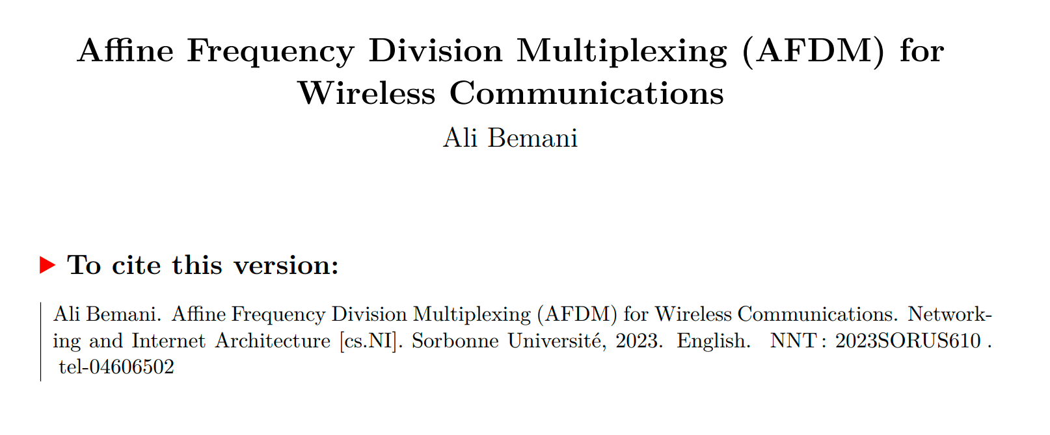
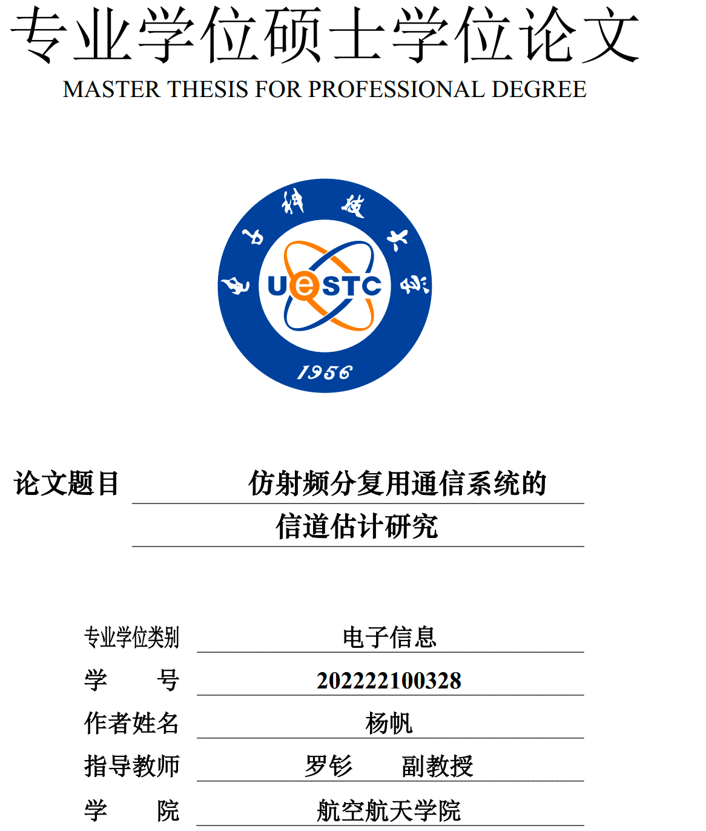

==================================================
Date: 2025-09-26 to 10-8 Topic: Literature Review - Underwater Acoustics (UWA) Channel Characteristics and Modeling
Summary of reports read:
- Key Feature 1 (Sparsity): UWA channels exhibit extremely long multipath delays, yet the majority of energy is concentrated in a small number of paths, demonstrating “sparsity.”
- Key Feature 2 (Time-Varying Nature): Due to factors such as water flow and platform movement, the Doppler effect in UWA channels is highly pronounced and rapidly changing, making it a typical “fast-time-varying” channel.
- Modeling Methods: Commonly employ ray tracing (e.g., Bellhop) or statistical models (e.g., AR(1)) to simulate its time-varying characteristics.
Ideas:
- The “sparsity” characteristic of UWA channels implies that sparse recovery algorithms (such as OMP) may be more efficient than traditional algorithms (such as LS) during channel estimation.
==================================================
Date: 2025-10-08 Topic: October Progress Meeting
Record of meeting:
- My Report: Summarized the principles of AFDM and the sparse, rapidly time-varying characteristics of UWA channels.。
- Further planning:
  - Channel Estimation (CE) Task: Since the UWA channel is sparse, you need to investigate and learn two estimation methods：
    - LS (Least Squares): As a benchmark method
    - OMP (Orthogonal Matching Pursuit): Leveraging the sparsity of the channel
  - Signal Detection Task:
    - Study the MMSE (Minimum Mean Square Error) algorithm, which is quasi-optimal but has high computational complexity.
    - Investigate decoding methods with lower computational complexity than MMSE, such as MP (Message Passing), EP (Expectation Propagation), and AMP (Approximate Message Passing), aiming to strike a balance between performance and computational complexity.
==================================================
Date: 2025-10-8 to 2025-10-15 Topic: CE Algorithm Study
Equation developments:
- LS estimation:
  - Model: $Y_{p}=H_{p}X_{p}+N$ (where p represents the pilot signal)
  - Solution: $\hat{h_{LS}}={\left(X_{p}^{H}X_{p}\right)}^{-1}X_{p}^{H}Y_{p}=X_{p}^{-1}Y_{p}$ (assuming X_p is a diagonalized derivative matrix)
  - Disadvantages: Does not utilize channel sparsity, resulting in poor performance under low signal-to-noise ratios and with fewer pilot signals, and is susceptible to noise amplification effects.
- OMP Estimation:
  - Leveraging the sparsity of h, treat CE as a sparse signal recovery problem.
  - Model: $Y_{p}=Φh+N$, where $Φ$ is the “perceiving matrix” formed based on the pilot position and the AFDM transformation matrix.。
  - Algorithm:
    - Initialize residual $r=Y_{p}$。
    - Iterate K times (sparsity)：
    - Find the column $j$ in $Φ$ that is most correlated with $r$。
    - ... [OMP Iteration Steps]...
  - Advantages: Theoretically enables more precise estimates with fewer pilot signals.
==================================================
Date: 2025-10-16 Topic: October Second Progress Meeting
Attendees: Yikun Guo (Student) , Yusha Liu (Supervisor)
Meeting Summary: This meeting is the second progress follow-up in October.
- Progress Report: I reported to my advisor on the learning outcomes regarding underwater acoustic (UWA) channel characteristics for this phase, which aligns with the task of “studying underwater acoustic channel modeling” scheduled for October in the project plan.
- Mentor Guidance: My mentor reviewed my learning progress and provided detailed explanations regarding the correct technical approach and key steps for modeling underwater acoustic channels using MATLAB, addressing my specific questions.
- Clarifying the Direction: The discussion helped me understand how to correctly implement the key characteristics of the UWA channel in simulation, particularly the impact of doubly selective filtering on AFDM systems.。
Action Items:
- Begin constructing the UWA channel model on the MATLAB platform following the correct path as guided by your advisor.
- Complete the preliminary channel model simulation and prepare to present the results.

==================================================
Date: 2025-10-15.to 2025-10-22 Topic: Detection Algorithm Study
Equation developments:
- MMSE Decoding:
  - Objective: Minimize $E\left[{\left|x-\hat{x}\right|}^{2}\right]$
  - Solution: $\hat{x_{MMSE}}={\left(H^{H}H+σ_{n}^{2}I\right)}^{-1}H^{H}Y$
  - Disadvantages: Involves inverting an $\left(N×N\right)$ matrix, with a computational complexity of $O\left(N^{3}\right)$, which is unacceptable in AFDM systems (where N may be very large).
- Research on Low-Complexity Algorithms (MP, EP, AMP):
  - AMP/EP: It is a special case of the G-AMP/G-EP framework, applicable to Bayesian inference, but its implementation is relatively complex.
  - MP (Message Passing / Belief Propagation):
    - Model the decoding problem as a factor graph
    - Iteratively compute the posterior probability of each transmitted symbol by passing “messages” (probability distributions) between nodes in the graph.
    - Advantages: The iterative process involves only addition and multiplication, avoiding matrix inversion and significantly reducing computational complexity.
==================================================
Date: 2025-10-22. to 2025-10-27 Topic: Detector Analysis & Selection
Ideas & Planning:
- Analysis: The O(N³) complexity of MMSE poses a bottleneck in both my simulations and future applications. MP algorithms (such as the Sum-Product algorithm for BPSK modulation) can approximate MMSE performance while offering more manageable complexity.
- Decision: The MP algorithm was ultimately selected as the low-complexity solution for performance comparison with MMSE.
==================================================
Date: 2025-10-30 Topic: (Simulation 1: Static Channel BER)
1. Simulation Target:
- Establish an AFDM simulation link。
- Channel: Static channel (channel does not change over time), including integer delay and Doppler shift
- Comparison 1 (CE): OMP vs LS
- Comparison 2 (Detection): MP vs MMSE
- Indicator: BER (Bit Error Rate)
2. Tabulated form:
Parameters | Value
AFDM Carrier Count (N) | 256
AFDM Symbol Count (M) | 16
Modulation scheme | QPSK
3. Plots & Outputs:
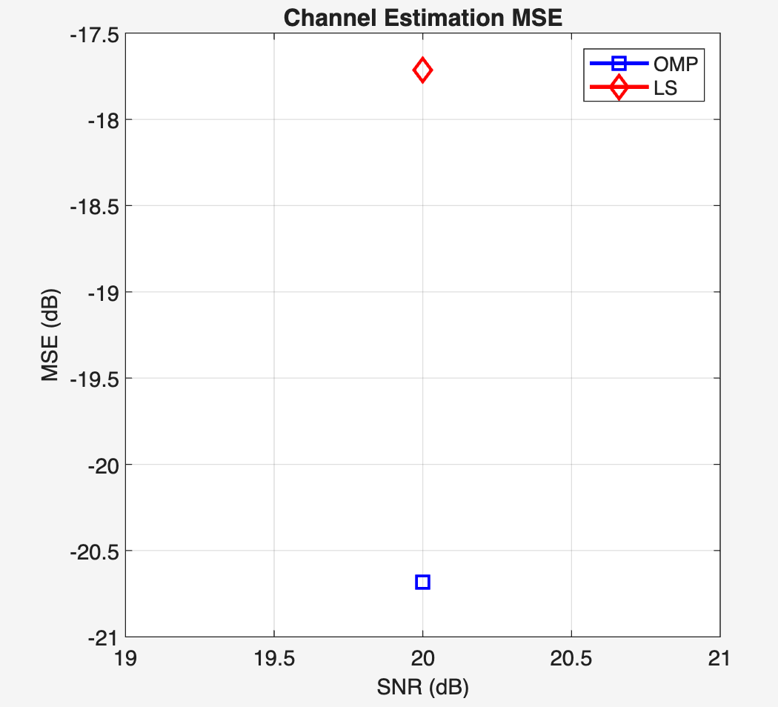
Chart Legend:
- Title: Comparison of NMSE Between OMP and LS Estimation Under Static Channels
- Horizontal abscissa: SNR (dB)
- Vertical ordinate: NMSE (dB)

- Chart Legend:
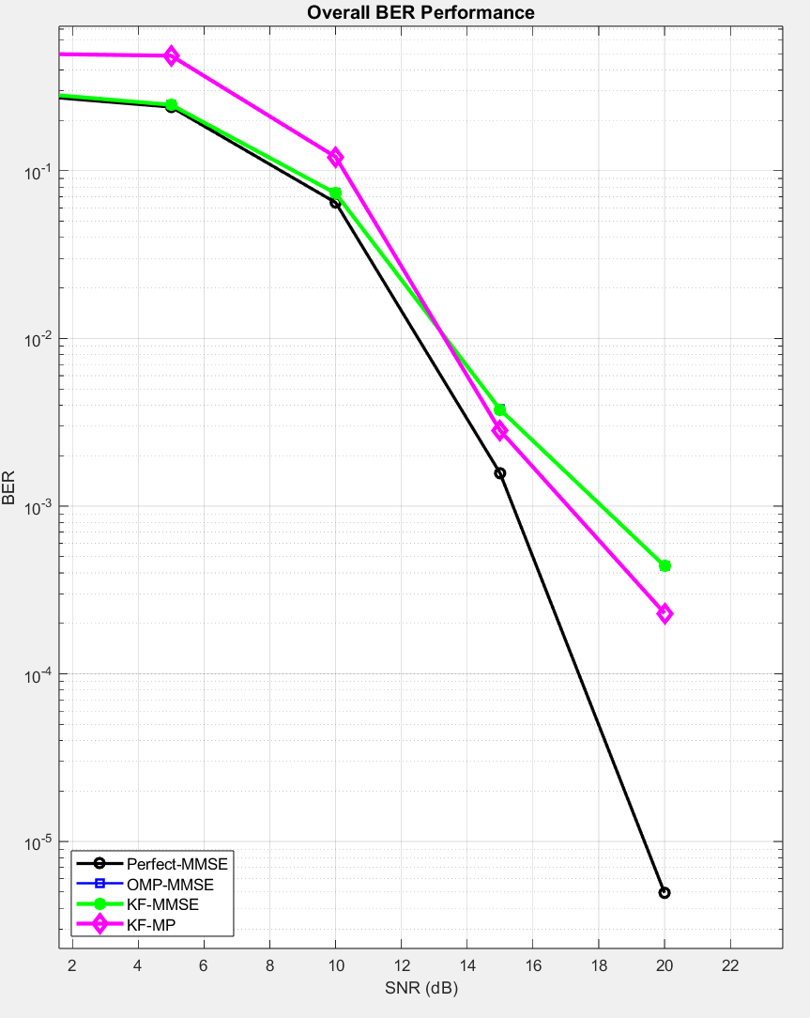
- Title: Comparison of BER Between MP and MMSE Decoding in Static Channels
- Horizontal abscissa: SNR (dB)
- Vertical ordinate: BER
4. Future Work:
- Complete static channel simulation and prepare analysis.
- Next step: Begin considering time-varying channels (channels that change over time), such as introducing an AR(1) model to simulate the channel's temporal correlation, and evaluate the algorithm's performance under time-varying conditions.
Logbook (Supplement): Nov 2025 – Jan 2026
Entry 1 — 03 Nov 2025
I started this phase by testing the AFDM receiver components under a generic high-Doppler time-varying channel (not yet UWA-specific). The goal was to see whether the AFDM input–output model in the delay–Doppler (DFS) domain really leads to a sparse effective channel matrix and whether that sparsity can be exploited by OMP (for estimation) and MP (for detection). I implemented the core sparse mapping and ran a small set of sanity checks (single-path and few-path cases) to confirm that the strongest energy lands on a small number of delay–Doppler bins.
Outcome: The sparse structure is visible and MP behaves sensibly when the support is “clean”. This gave confidence to build the receiver around sparse modelling rather than dense equalisation.
Supervisor interaction: I shared the initial high-Doppler sanity checks and my plan to exploit sparsity in the AFDM input–output model. My supervisor agreed this was a sensible starting point and suggested keeping a clean “perfect-CSI reference” in early tests to separate estimation error from detector behaviour.
Entry 2 — 10 Nov 2025
I extended the generic high-Doppler tests to multi-path settings and started comparing serial pipelines: (i) one-shot OMP channel estimate followed by detection, and (ii) direct MP detection under a known channel (perfect-CSI reference). In these tests, the detection performance became clearly sensitive to gain errors even when delay/Doppler locations were approximately correct. This suggested that “getting the support right” is only half of the problem; refining gains matters a lot once pilots/data interfere or the model is not perfectly on-grid.
Outcome: Identified gain mismatch as a dominant cause of BER degradation in estimated-CSI cases, motivating a receiver that can refine gains rather than freezing them after estimation.
Entry 3 — 18 Nov 2025
I began switching focus from the generic time-varying channel to underwater acoustics. I read background material to align the modelling assumptions with UWA physics (strong time variation, frequency selectivity, few dominant paths, and Doppler behaving more like time scaling than a simple CFO). I also collected references that describe practical UWA channel simulation and modelling details.
Key references reviewed:
- Zhou & Wang, OFDM for Underwater Acoustic Communications (2014).
- Chaves, Modeling and Simulation of Underwater Acoustic Communication Systems (2016 thesis).
- Chaves/Martins/Diniz, Modeling and Simulation of Underwater Acoustic Communication Systems (2017 conference paper).
Outcome: Clearer picture of why Doppler scaling and sparse multi-path dominate UWA design choices, and what parameters are typical in simulation (delay spread, sparse paths, motion-induced Doppler).
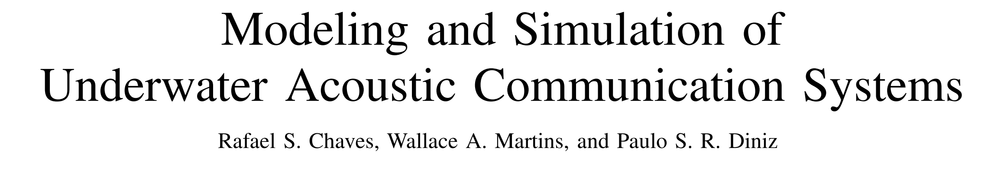
Supervisor interaction: I updated my supervisor on the shift toward underwater acoustics and the key modelling differences (time scaling Doppler, sparse paths). My supervisor suggested using a standard UWA reference text to justify modelling choices and to clearly state how Doppler is represented and discretised in the simulations.
Entry 4 — 01 Dec 2025
I moved from “high-Doppler toy channels” to an underwater-style channel model and worked on a practical way to discretise it into the receiver’s delay–Doppler grid. The key engineering decision was to keep the receiver model compatible with a sparse DFS representation: represent the channel as a limited number of dominant components, map delays to integer sample indices, map Doppler scaling to normalised Doppler and quantise it into integer Doppler bins, then build the effective AFDM channel matrix accordingly. I also ran a short “test channel” pass to determine maximum delay and Doppler bounds to set guard regions and avoid invalid parameter combinations.
Outcome: UWA channel parameters can be converted into a usable sparse delay–Doppler support; guard settings and effective block length become well-defined for the AFDM chain.
Entry 5 — 12 Dec 2025
With the UWA mapping in place, I revisited the receiver structure. The serial approach (one-shot OMP → freeze channel → detection) is simple but the earlier tests suggested it is fragile when gain estimation is imperfect, especially under superimposed pilots where data acts as interference during estimation. I therefore drafted a joint receiver idea: use OMP only once to lock the delay–Doppler support (i.e., delays and Doppler bins), then refine only the complex gains while detecting data, rather than re-searching the full grid. This keeps complexity low because the refinement step is low-dimensional (size P) and avoids the heavy cost of dense MMSE inversion.
Outcome: A concrete receiver design direction emerged: “support from OMP once; gains refined iteratively with detection.”
Supervisor interaction: I proposed the idea of running OMP once to lock the delay–Doppler support and then refining only the gains jointly with detection. My supervisor agreed this aligns with the project goal of low-complexity receivers and suggested I highlight the difference between “serial estimation→detection” and the “joint refinement loop” as the main contribution in the interim report.
Entry 6 — 22 Dec 2025
I implemented the proposed joint iterative receiver in MATLAB. The structure is: first run OMP to obtain the sparse support 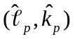 and an initial gain estimate; then perform a small number of outer iterations where (a) MP produces a symbol estimate given the current channel, and (b) a regularised LS step updates the gain vector on the fixed support using the current reconstructed transmit block (data estimate + known pilot component). Importantly, delays and Doppler bins remain fixed after the first OMP step; only gains are updated. I added damping/early-stop logic to stabilise the iteration.
Outcome: The joint scheme runs end-to-end and produces BER curves without numerical instability. Compared to the serial baselines, the BER improves in the tested settings while the algorithm stays lightweight (no 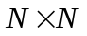 dense inversion).
Entry 7 — 07 Jan 2026
I consolidated results for the interim stage. I ran Monte Carlo experiments over an SNR grid and collected both BER and channel estimation error (NMSE) metrics. I also began writing down the complexity comparison in a way that matches the implemented pipeline: LMMSE/MMSE as dense references, OMP-based serial baselines, and the proposed joint (OMP support + MPLS gain refinement). The key point is that the joint method keeps the support fixed after OMP, so the refinement cost is dominated by sparse MP updates plus a small 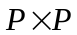 LS solve per outer iteration, which scales much more gently than dense MMSE.
Outcome: Ready-to-use figures/tables for the interim report, plus a clear narrative: “serial estimation freezes errors; joint refinement reduces BER without blowing up complexity.”
Entry 8 — 20 Jan 2026
I reviewed the end-to-end consistency of the MATLAB implementation: parameter logging (effective block length after guard, delay/Doppler bounds), reproducibility (random seeds), and fairness across compared methods (same channel realisations, same SNR points, consistent stopping criteria). I also wrote brief notes on limitations that should be stated explicitly in the interim report: grid quantisation (off-grid Doppler), sensitivity of OMP to dictionary window size, and the fact that the current work is single-user, while multi-user modelling and multi-user detectors are planned for the next phase.
Outcome: The interim narrative is coherent and defensible: model → implementation → results → limitations → future work.

